My Sessions and Hosts
Use this page to view assigned virtual machines, connect to desktops, manage your current session, and perform self-service power actions.
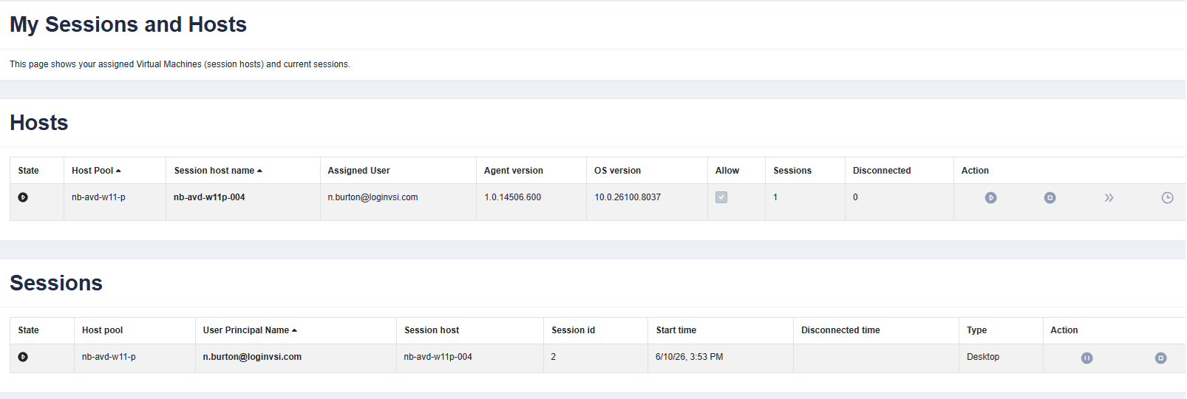 | At a glance  - Hosts are the virtual machines assigned to you.  - Sessions are your active or disconnected logins.  - Action icons appear at the right of each row.  - Save work first before logging off, stopping, or restarting.  Tip: host actions affect the entire machine; session actions affect only your login.
Common tasks
Power operations | Connect or manage sessions | Self-service auto-start
- Power on: in the Hosts row, select the play/power icon and wait for the host to become available.  - Power off: use the stop/square icon only after saving work and closing apps.  - Restart: use the restart action when instructed or when a fresh VM session is needed.  - Schedule: use the clock icon to set an automatic start time, saving you login time by pre-warming the desktop. Try to target 15 minutes before you typically come into the office. See “Self-service auto-start” for additional details. | - Connect: open the host/session action when the VM is powered on and ready.  - Disconnect: leaves programs running so you can reconnect later.  - Log off: ends the session and closes running applications; save files first.  - Check status: review State, Sessions, and Disconnected before taking action. | - Open schedule: select the clock icon in the Hosts action column.  - Enable: check Enabled, choose weekdays, start time, and time zone.  - Save: select OK. Pick a start time before your workday so the VM is ready.  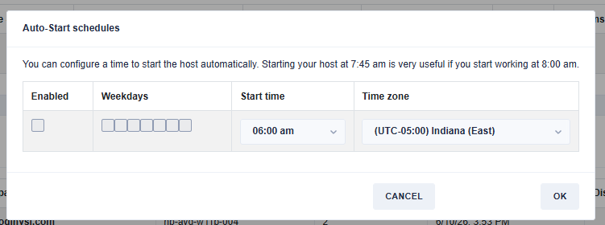
Need help? Use Feedback or contact your support team if power actions fail, the host stays unavailable, or your session will not log off.

